|  |  |
| --- | --- |
| HOSPITAL management system SOFTWARE  USER GUIDE | Abstract  User Manual For All Guidance to the Software |

**COPYRIGHT INFORMATION**

**SHUBHAM KUMAR 170101064**

**KEERTI HARPAVAT 170101031**

**P.R.S RAKESH GUPTA 170101050**

**K. NAVEEN 170101032**

**PRABHAT KUMAR 170101046**

CONTENTS

1. ABOUT THIS DOCUMENT

Intended Audience………………………………………………………………… 3

Additional Hospital Database Documents……………………………………… 3

1. Overview of the Software

Hospital Database Software…………………………………………….………….4

1. Using of the Hospital Database Software

Opening of software………………………………………………………………….5

Admin Page……………………………………………………………………………8

Doctors Page………………………………………………………………………….11

Patient Page………………………………………………………………..…..……..12

Pharmacist Page …………………………………………………….……………….13

* Medicines………………………………………………………………………13
* Billing…………………………………………………………………………...15

1. Others

Cautions………………………………………………………………….…………….17

1. ABOUT THIS DOCUMENT

Intended Audience

This document is intended to be used by Hospital administration for storing complete Record of doctors, staff, and pharmacy. This document will be used in concert with the Database to configure (Adding, retrieve) your hospital’s record to get all the details of Appointments, Medicine and staff including doctors. The software takes cares of essential requirements of data in the hospital. It helps to maintain all the data without any worries of papers.

Additional Hospital Database Documents

* Read Technical Documentation for showing the process, How the processes are working in the Software.
* For any other query and help mail at <mailto:abc@gmail.com>

1. Overview of the Software

Hospital database Software

Hospital Database Software is developed to handle all medical records easily. The Data may be Doctor’s Information, Staff Information, Pharmacy Information, Patient Information.

The Software uses the MS ACCES Database.

The software can be used to:

* Adding and searching Doctor’s Information (Name, Department, Appointment Information etc.).
* Adding and Searching details of Staff.
* Booking Appointments with Doctors for patients.
* Pharmacy details.
* Add Medicines
* For Billing
* Emergency Contacts

The Starting of software contains different buttons for different persons:

* Doctor: For Details Related to Doctors.
* Admin: For controlling all the details and changing handling all the details of staff and records.
* Patient: They can get the appointment by giving their information.
* Pharmacist: For pharmacy related issues. Only permitted people have permission to log in.
* Emergency: In case of any emergency people can get all the details related to hospital and their admission.3. Using the Hospital Database Software

Opening of software



Figure 1/ Opening Page Of Software

The Opening Page enable you to go to the form according to your Designation.

* The Initial Log In Details for

1.Admin: [Username:admin],[Password:admin]

2.Pharmacist: [Username:pharmacist],[Password:pharmacist]

3.Staff: [Username:staff],[Password:staff]

***These can only be changed by the admin

Bottom of the page Contains the contact details of hospital.

Purpose of different buttons:

**Emergency**- A page opens describing the details of Ambulance and Asking for details of emergency and Age.

After Processing it will Automatically send an Email of Confirmation.

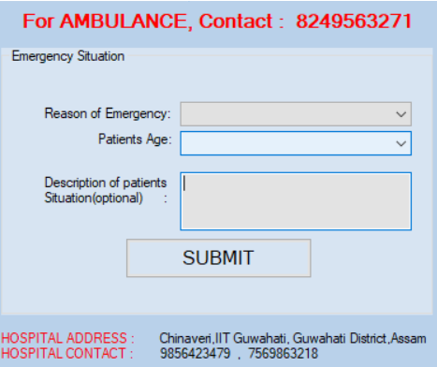

Figure 2 /Emergency Page

* **Doctor**- Send you to the Login Page of Doctor. The page asks doctor to enter his credentials, Username and Password Provided by Administrator.

If the entered Details do not match with that in database a Message box appears saying that “Username or password is incorrect”.

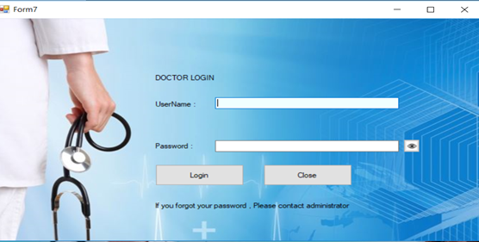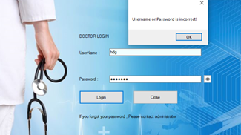

Figure 3Login Form For Doctors

* **Admin**- The Login Page appear for Admin as like as Doctor. Only one User has permission to Go to admin page.

NOTE: For this Software

Admin User_Name: admin

Password: admin

Change Password allow admin to change the password.



Change Password

Figure 4Page For Admin Login

* **Pharmacist**- The Login Page appears as like as Mentioned Above for Doctor.
* **Patient**- Login page appears as like as of doctor and patient.

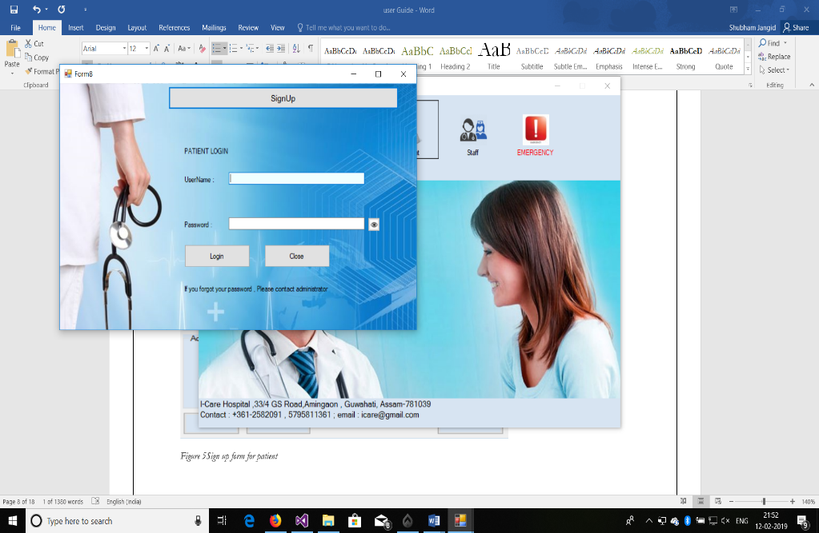

Sign up

Figure 5/ Patients Login Form

If there is no username for the patient, then user also can sign up by adding his/her details.

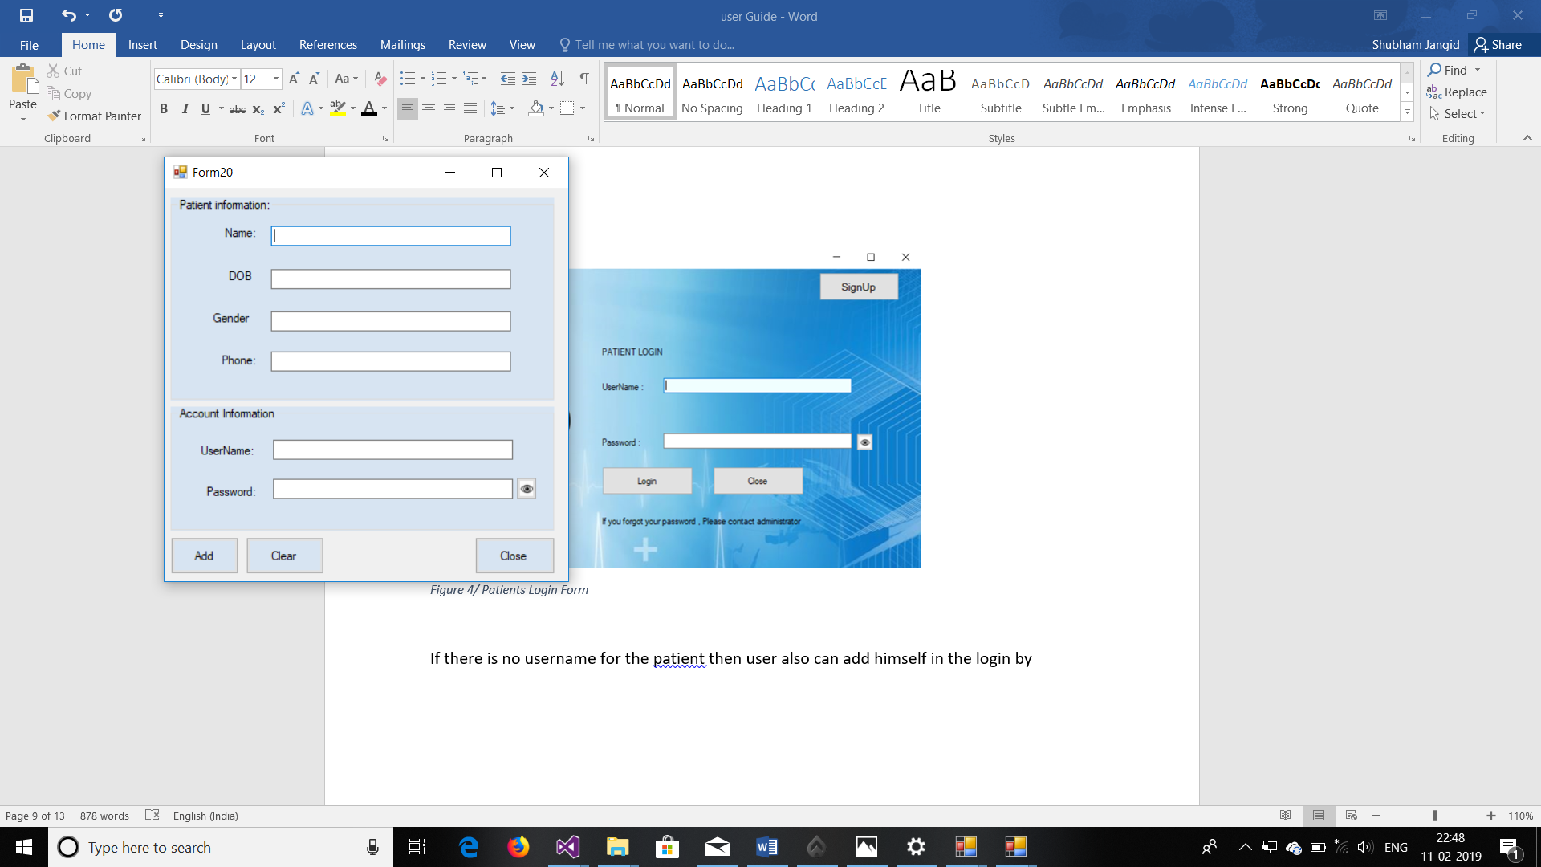

Figure 6Sign up form for patient

Add will add patient in the database of the software.

And other labels of Textboxes have their respective meanings.

After successfully signup patient can enter into his page.

After Successful Login Different Pages Open for different designated persons. Below is detailed information about different logins.

Admin Page

Buttons

Following Page Opens After login of Admin

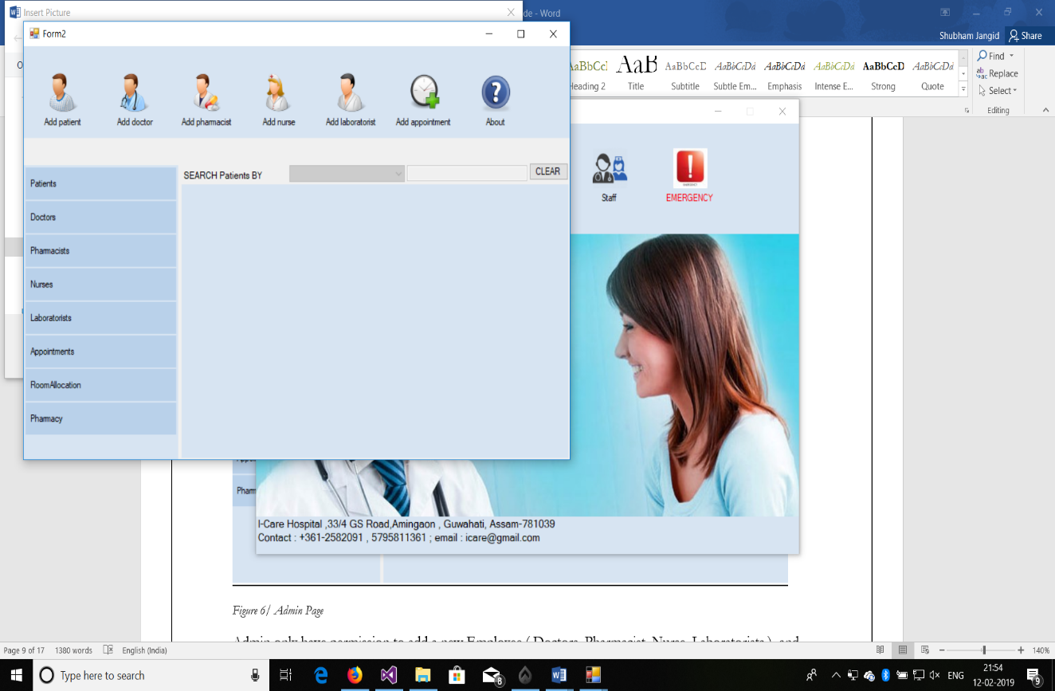

Figure 7/ Admin Page

Admin only have permission to add a new Employee ( Doctors, Pharmacist, Nurse, Laboratorists ) and patients .

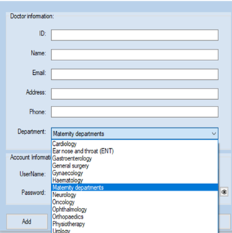 Admin have to Enter the details of person which he wants to

Figure 8/ Doctor addition form

Add. On clicking Add the details Automatically will add to the

Database of the Software.

Close button closes the page.

Clear button clears all the input of the Textboxes.

Software Automatically send confirmation Email with

all the details to the person who is just added.

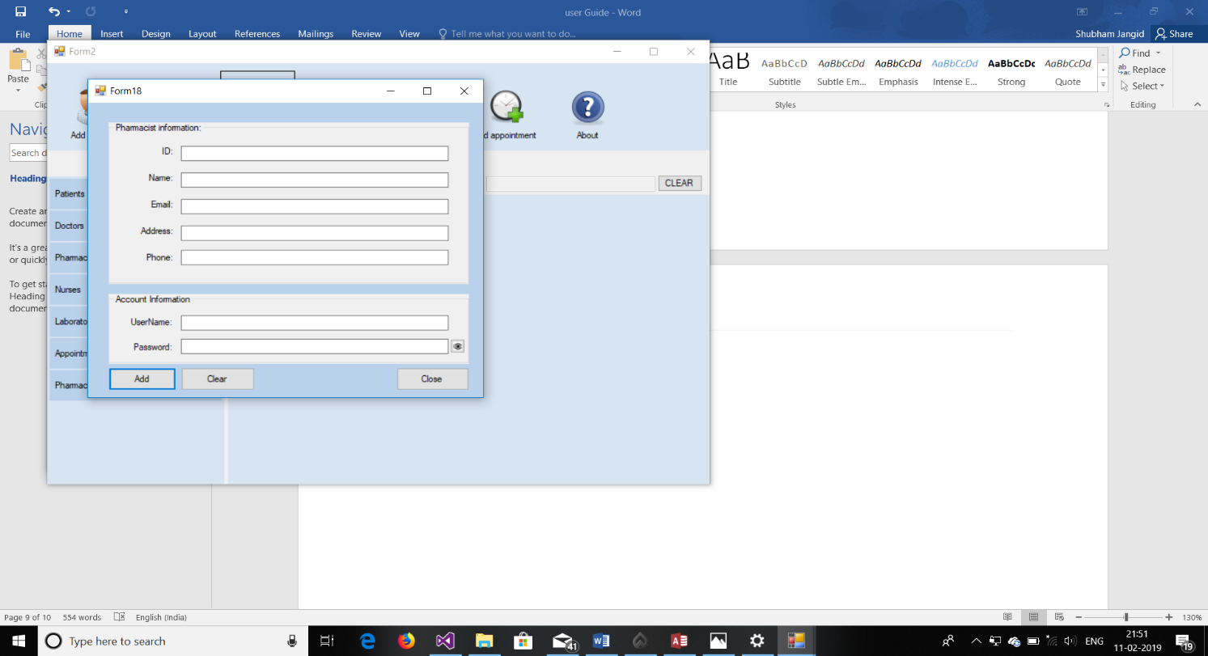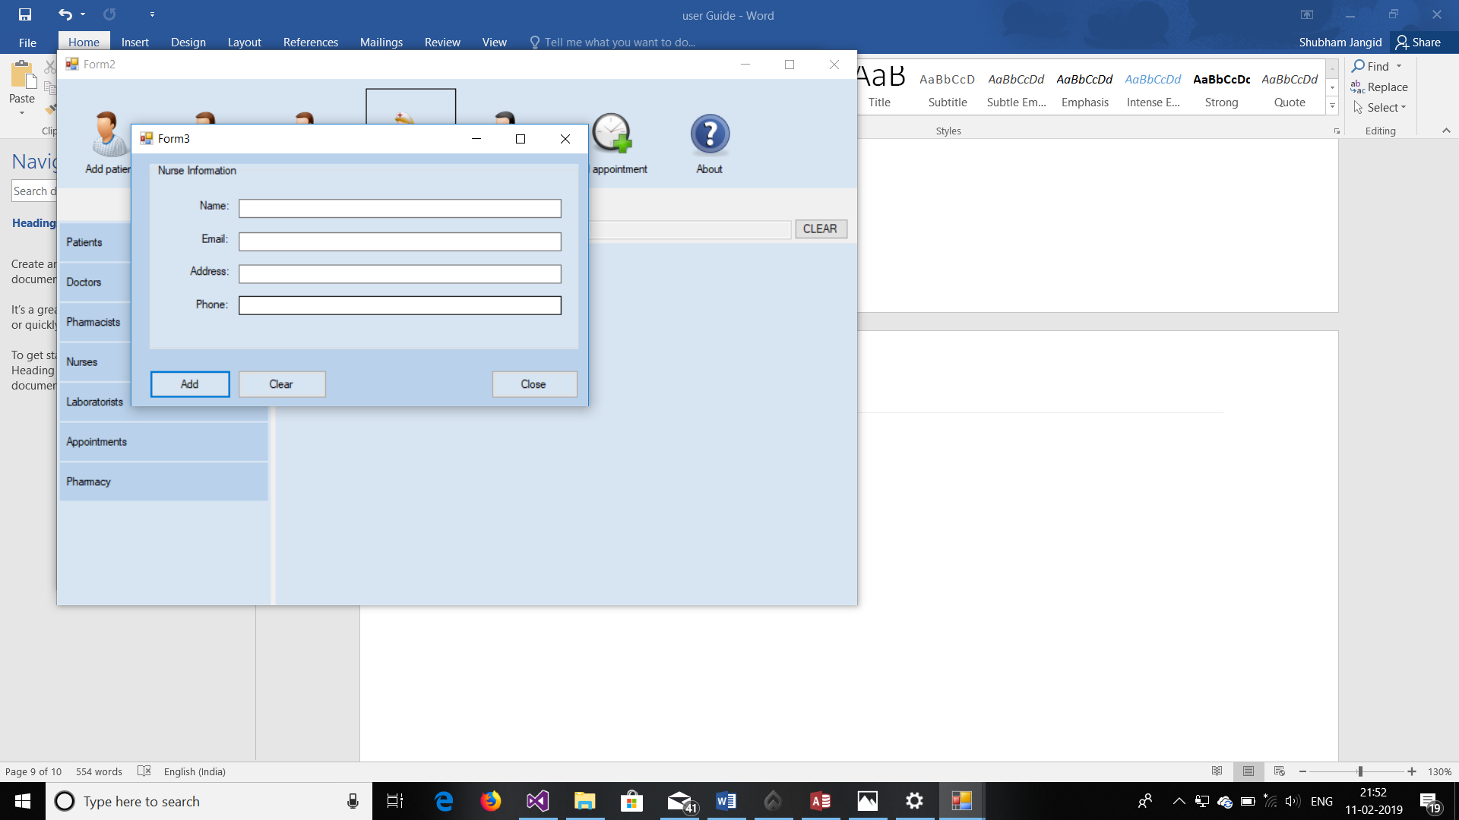

Figure 9/ Adding of Pharmacist

Figure 10/ Addition of Nurse

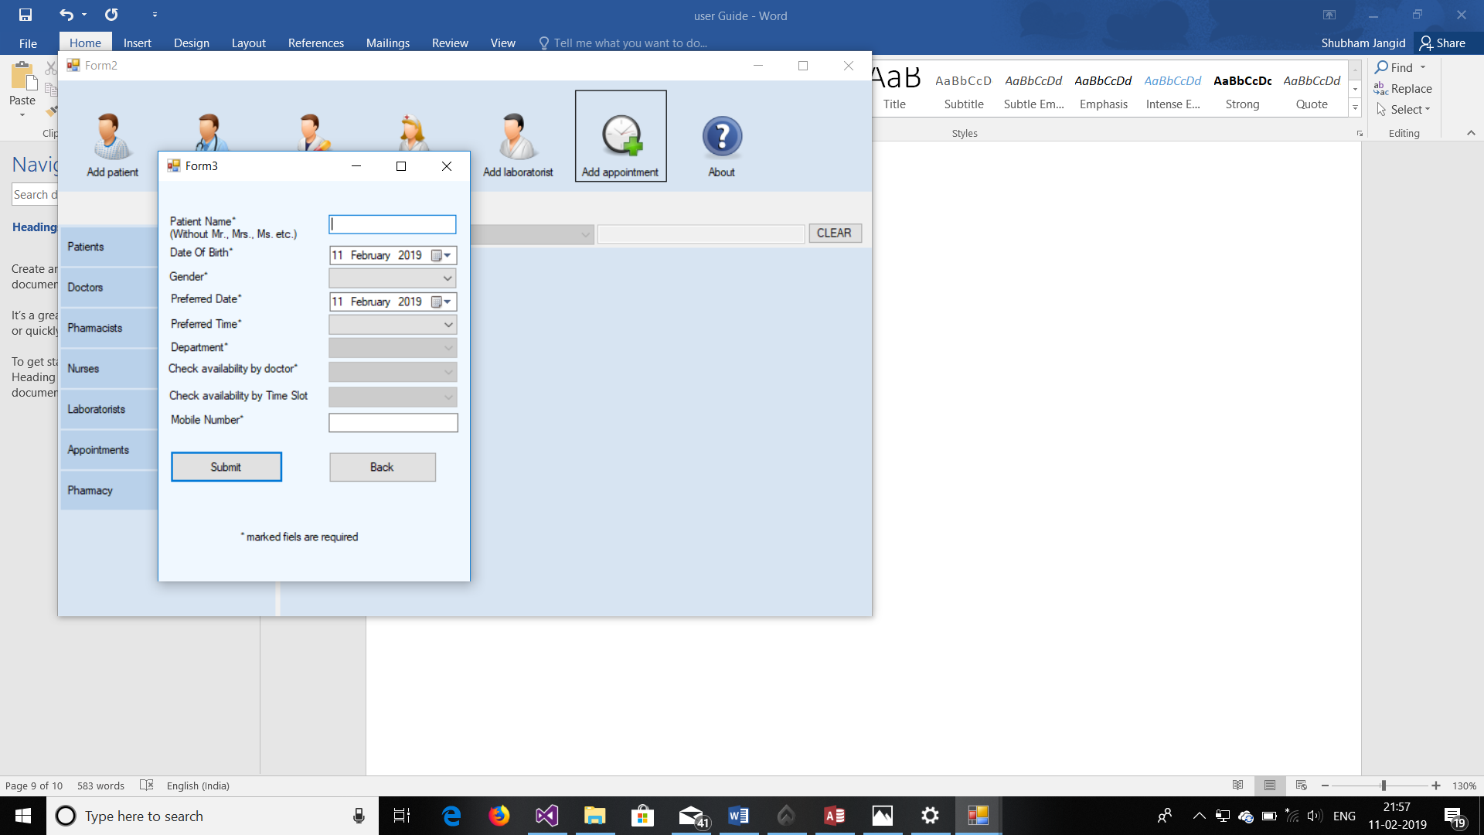

Figure 11Patient Add

Figure 12 Addition of appointment for patient In adding an appointment for patient the form accepts the detail asks for the details of patients.

The form allows admin to give time and date for the appointment. When User clicks on submit button the software search if there is any appointment possible for time slot and selected doctor.

If it is preferable than it will send email to patient about the status.

In the taskbar we have options to see what is there in the database for those options and the form shows all the details based on option selected in taskbar and combo box near search.

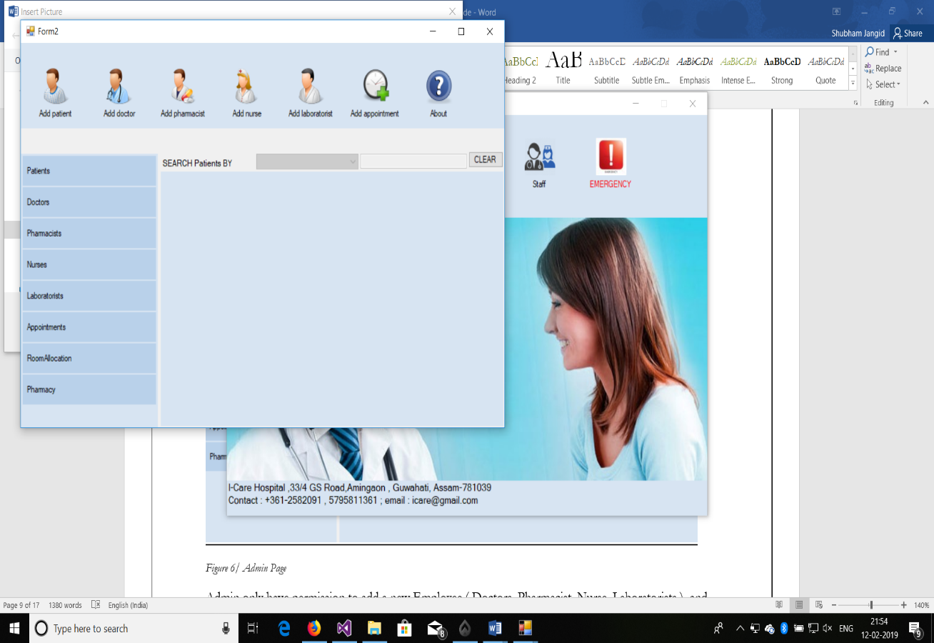

Taskbar

Figure 13/ Task bar of Admin Page

The Form in taskbar(lined Area) contains different option for showing the details of given persons which are:

* Doctors: shows the details of doctors in the database of form.
* Patient: shows the details of patients.
* Pharmacists: shows the details of pharmacist.
* Nurses: shows the details of nurses.
* Laboratorists: shows the details of Laboratorists.
* Appointments: shows the details of appointments.
* Room Allocation: It will direct user to the room allotment form.
* The pharmacy option Just opens the form of pharmacy which is described in later part of this manual.

Allocate Room

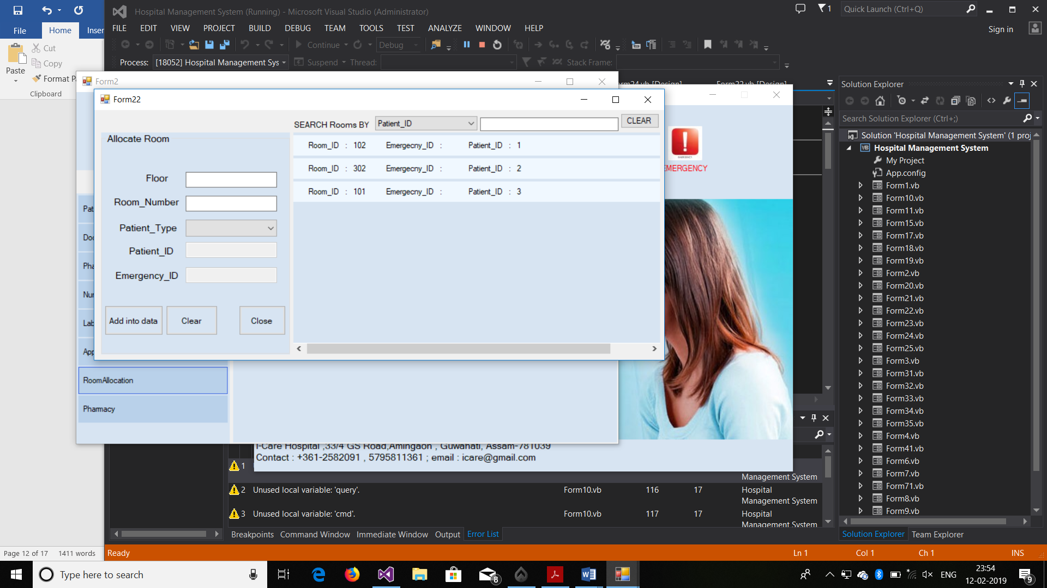

Details of Room

Figure /Room Allotment Form

This is all About Admin page.

Doctor Page

When you will login as doctor the following form opens which Give details of Doctor

(Username, Name, Department, Phone Number, Email).

In Taskbar form shows the details of appointments of doctor which can be sorted by

Date, patient ID and Name.

Close Button closes the form.

Edit button Enables Doctor to edit his details.

: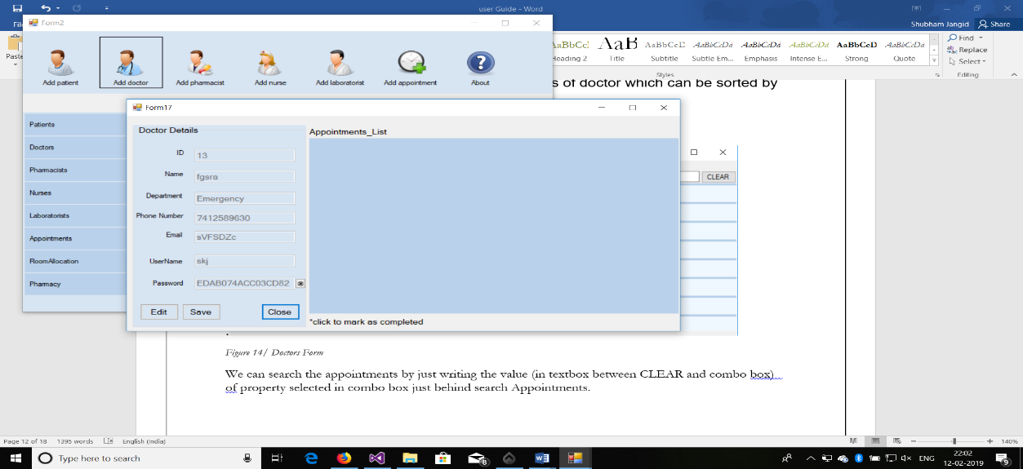

Figure 15/ Doctors Form

We can search the appointments by just writing the value (in textbox between CLEAR and combo box) of property selected in combo box just behind search Appointments.

Patient Page

On Successful Login, Patient can see all its details. The Following form appears.

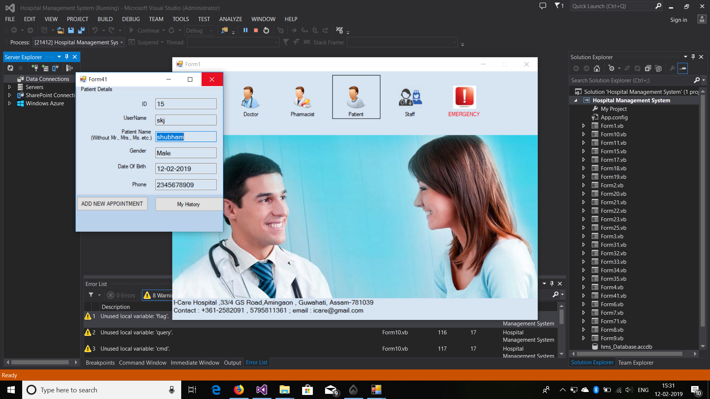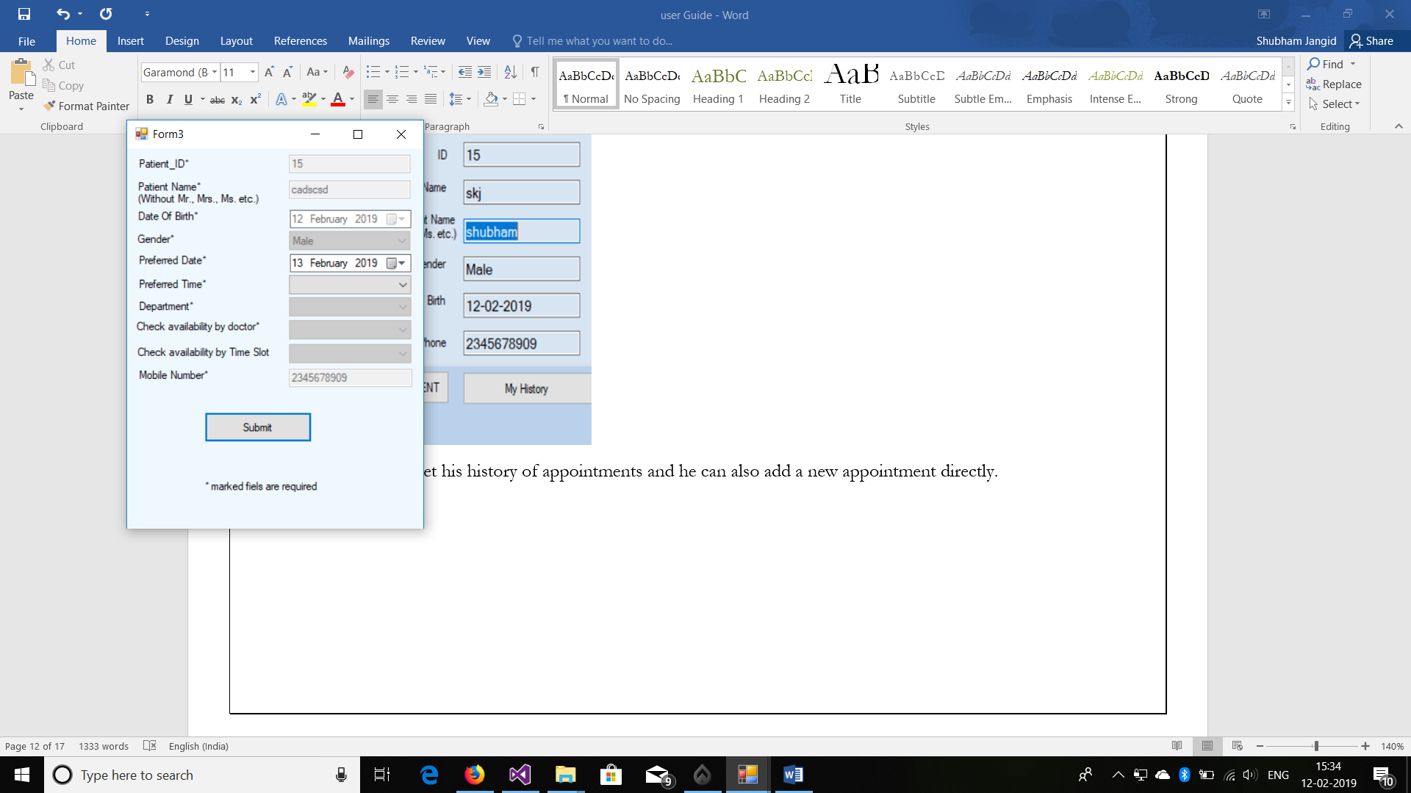

Figure 16/ adding a new appointment for patient

In this he can get his history of appointments and he can also add a new appointment directly.

Pharmacist Page

On Successful Login of pharmacist, the pharmacy form open which is:

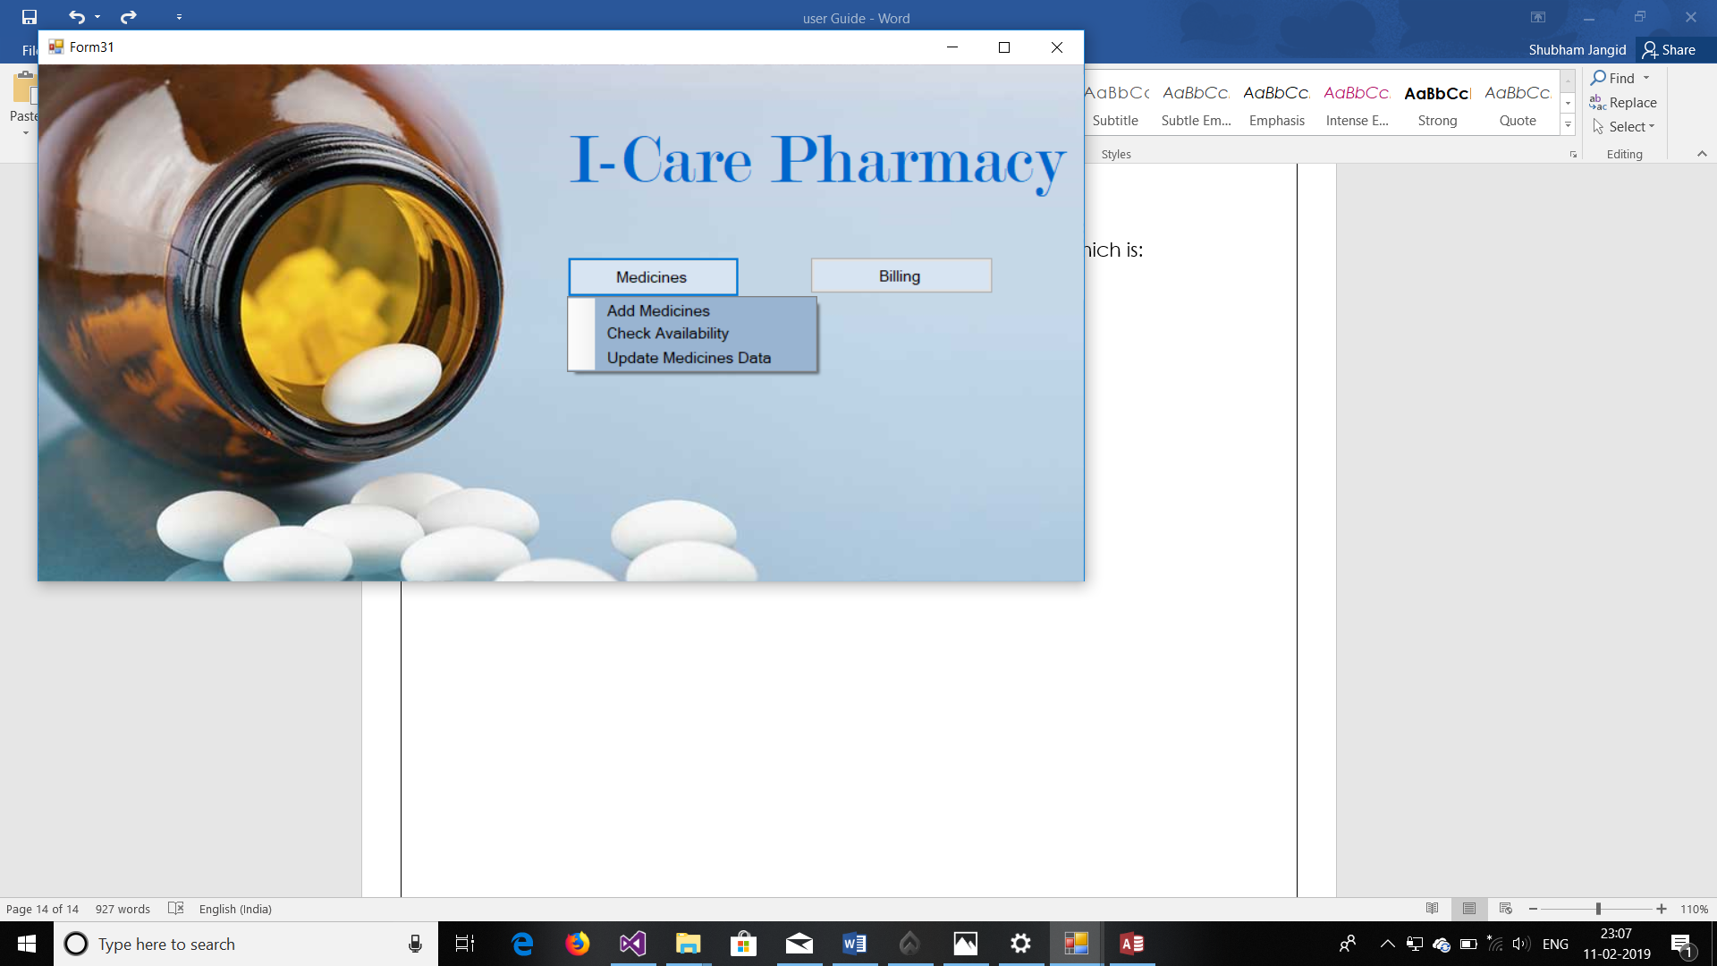

Figure 17/Pharmacy Form

The page contains two buttons:

* Medicines: Further contains Three sub buttons:
* Add Medicines
* Check Availability
* Update Medicines Data
* Billing: For billing purpose of pharmacy.

The Detailed Information about these two is below:

Medicines:

Eid(Primary Key) is the specific id of medicines which contains 3 characters and 4 last digits.

Medicines Contain three sub buttons which have their respective meanings, Functionalities of them are as:

1. **Add Medicines**

On clicking it the below form opens, it will ask for details of the Medicine (Eid, Name, Rate, Quantity, Expiry date).

On Clicking Add into data it stores the data of the Medicine.

And clear resets the text of textboxes. Close closes the page.

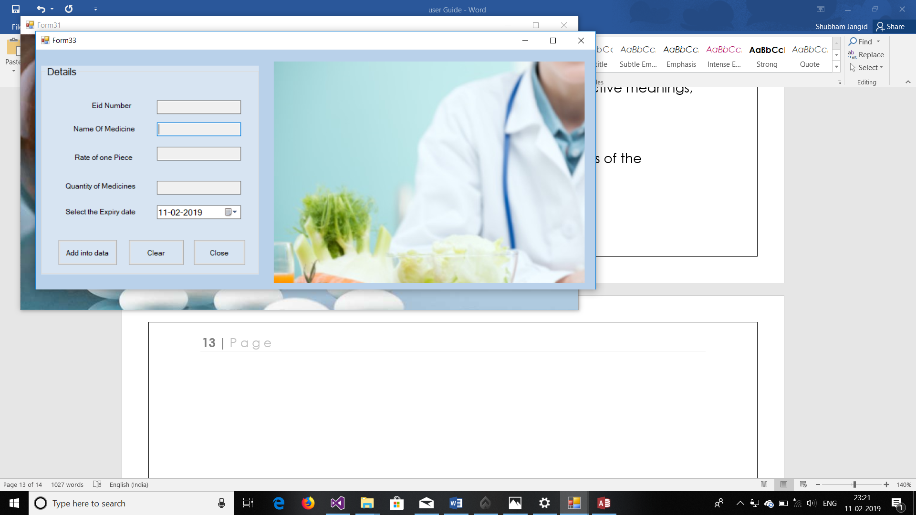

Figure 18/Add Medicine form

1. **Check Availability**

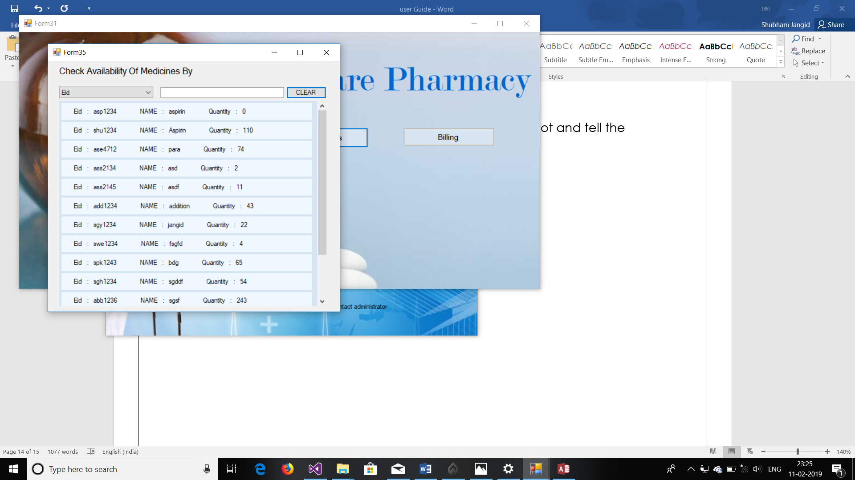

Figure 19/ Check Availability of Medicines

On clicking check Availability, the form shows all the details of the medicines in Database. We can sort the results by selecting Property (Eid or Name) in Combo box and typing its value in textbox.

1. **Update Medicines Data**

We can also update the quantity of medicine in the data if new tender just came and you want to update the data of medicines, then we can just do it by typing the name and Eid of the medicine.

Figure 20/ Update Data Of Medicines

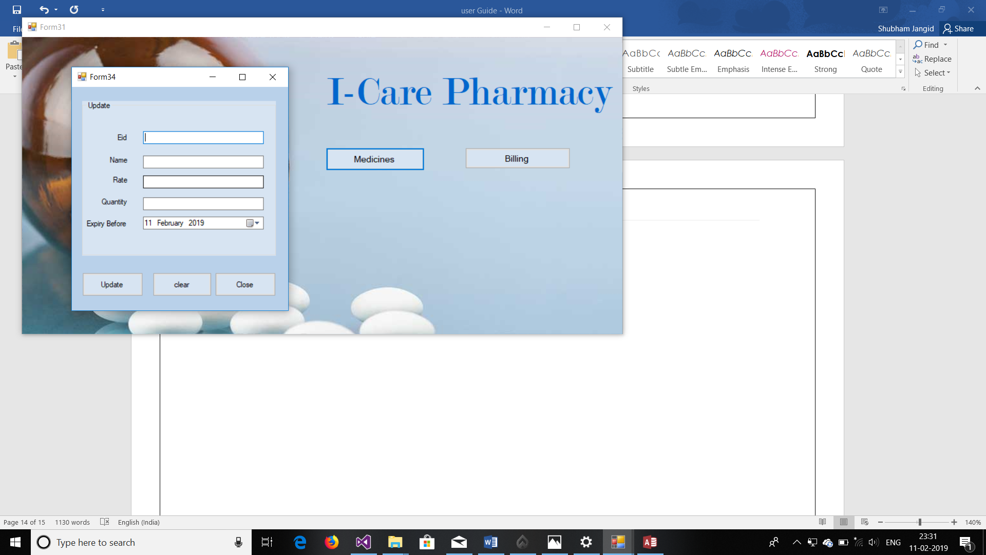

We can also change all the details of the

Medicine If its Eid is already in the data.

Billing:

Billing is made for Billing purpose of Pharmacy.

Just looks like As: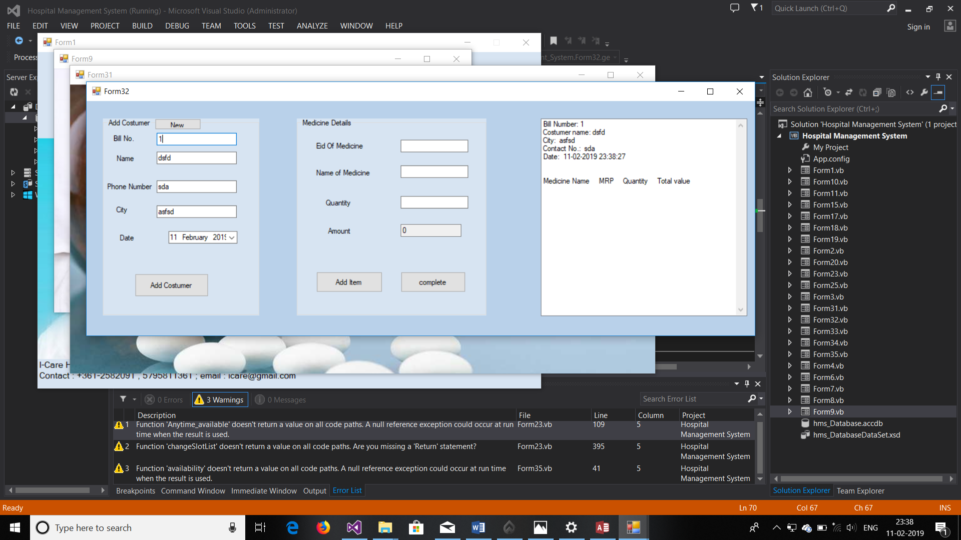

Figure 21/ Basic Details Of costumer

On clicking Billing above form open.

When You will click on new it will generate bill number and asks for details of costumer like name, City, phone.

And after click on Add Costumer bill is generated as list.

Finally, we can just add details (Eid, name, quantity) of Medicines in Medicine Details Group. Which will Automatically update the list. If there are less number of medicines in data, then it will Automatically give message of quantity left in the stock

Complete button just gives the total money and off the details of that costumer.

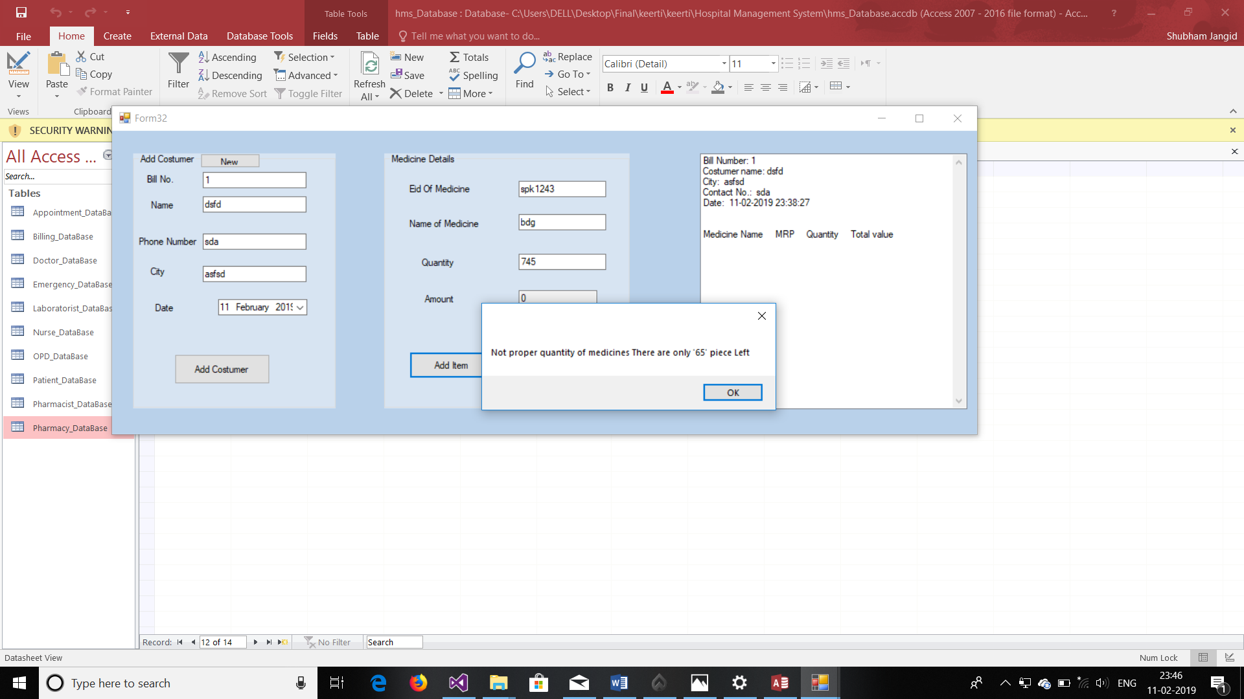

Figure 22/ Addition of data in billing

4.OTHERS

Cautions

* In Pharmacy Eid of medicines should be Different.
* Admin Password must be Very Secure.